OADTurk

Group 6

Aleksandar Stojcic

Stefan gajanovic

Amir Mujacic

Aleksa pandurevic

Djordje Rajic

Nikola balac

2017

Contents

Task 1. 2

Task 2 3

OADTurk Introduction 3

Project utilization 3

Target audience 3

The most important OADTurk Use Cases (with priority) 3

Description of Use Cases 4

Use Case Diagram 8

UML analysis class diagram 8

Project plan 9

Screenshots 9

Resource estimation 14

Risk factors 15

Our team 15

# Task 1.

Our first task was to create a UML Diagram in Visual Paradigm, from the text we were provided. 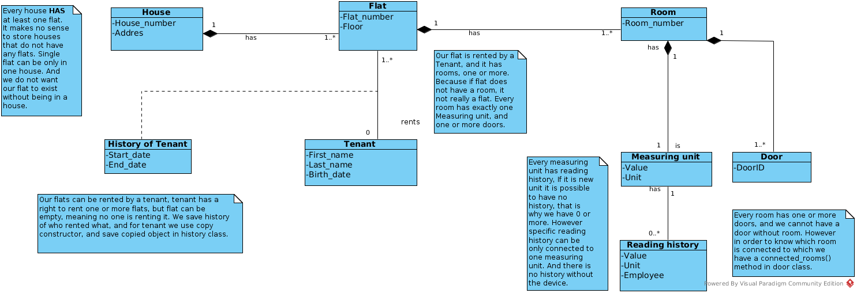

Figure 1. UML Diagram

In our case UML Diagram shows, that every house has at least one flat. We do not have need to store houses that do not have any flats. We also do not want flat to exist without house. These flats can be rented by tenants, however we do save some basic data about tenant and history about which flat was rented when. Flat has one or more rooms, we chose one or more, because if we do not have any rooms that is not really a flat. Each room consists of one measuring unit, and we keep history of every measuring unit. Every room has one or more doors, and we cannot have a door without room. However because it is required to know which room is connected to which we have a connected_rooms() method in door class, so we can get this information.

# Task 2

## OADTurk Introduction

OADTurk is a learning environment based on human computation, that can be used by users. This software is central environment for the administration of learning applications(LAs). Learning applications are central components of OADTurk. Our goal is to make increasing number of learning applications. The two main parts of OADTurk are: “OADTurk User Community” and “OADTurk Environment”.

## Project utilization

The customers can use OADTurk for multiple reasons. One of the most important is participating in different learning applications. Every user can choose different learning units. For every different LAs user has possibility to participate in different type of exams. There is also possibility for every user to apply for “creator”.

## Target audience

The target audience for our software is actually every person who wants to acquire new knowledge. OADTurk is also very helpful for students during their studies. Human computation offers every person to learn their learning units on efficient way. To narrow out our target audience a little bit, we could say that anyone with a desire to learn new things, and help other do the same would be interested in a project like this. OADTurk give you the opportunity to takes exams, and learn from Learning Applications created by other people, but one can also make their own applications in learning unit, with time, one can become creator.

## The most important OADTurk Use Cases (with priority)

|  |  |
| --- | --- |
| **Use Cases:** | **Priority** |
| Registration | High |
| Sign In | High |
| Sign Out | High |
| Applying for Creator | Average |
| Participating in exams | Average |
| Users Learning Applications | High |
| Adding Creators | Low |
| Managing user’s requests | Average |
| Managing user’s account | Average |
| Creating exams | Average |
| Creating Learning Application | Low |
| Changing personal info | High |
| Defining categories | Low |

## Description of Use Cases

|  |  |
| --- | --- |
| Use Case: **Registration** | Priority: **High** |
| *Description*  Performing registration for OADTurk application. | |
| *Scenario 1*  A user enters their registration credentials. Then presses button “Register”. Dialog “The authentication E-Mail has been sent to your address. Please verify it and try Signing in” is shown. | |
| *Scenario 2*  A user enters their registration credentials. Then presses button “Sign in”. He will be then redirected to the welcome tab. | |

|  |  |
| --- | --- |
| Use Case: **Log In** | Priority: **High** |
| *Description*  Log in into OADTurk application. | |
| *Scenario 1*  A user enters their credentials. Then presses button “Sign in”. Upon successful authentication the user shall be redirected to the OADTurk tab. | |
| *Scenario 2*  A user enters their wrong credentials. Then presses button “Sign in”. Because of the wrong authentication the user can not be redirected to the OADTurk tab. | |

|  |  |
| --- | --- |
| Use Case: **Log Out** | Priority: **High** |
| *Description*  Sign out from OADTurk application. | |
| *Scenario 1*  A user presses button “log out” and will be redirected to welcome tab. | |

|  |  |
| --- | --- |
| Use Case: **Users** **Learning Applications** | Priority: **High** |
| *Description*  A user is enabled to switch over different Learning Applications. | |
| *Scenario 1*  A user can choose different Learning Application. For every Learning Application users got different questions to solve. After choosing appropriate answer, the user will be click on the button “Submit”. | |

|  |  |
| --- | --- |
| Use Case: **Changing personal info** | Priority: **High** |
| *Description*  Changing personal info of the user. | |
| *Scenario 1*  A user enters their registration credentials additionally with new password. Then presses button “Save”. If the old password was correct, new password will be successfully created. | |
| *Scenario 2*  A user enters their registration credentials with wrong old password. Then presses button “Save”. Because of the wrong old password, the user can not be enabled to change password. | |

|  |  |
| --- | --- |
| Use Case: **Applying for Creator** | Priority: **Average** |
| *Description*  Every user is enabled to apply for creator. | |
| *Scenario 1*  A user is still creator and is enabled to create new Learning Applications, which must be confirmed by admin. | |
| *Scenario 2*  A user applies for creator, and wait for admins to evaluate his request. | |

|  |  |
| --- | --- |
| Use Case: **Participating in exams** | Priority: **Average** |
| *Description*  Every user has a possibility to participate in exams. | |
| *Scenario 1*  A user wants to participate in an exam, but he is unregistered. By a click on a button “Register”, he can be registered and then to participate in an exam. | |
| *Scenario 2*  A user is registered and by a click on a button “Start”, he will be redirected to new tab with questions. | |

## 

## Use Case Diagram

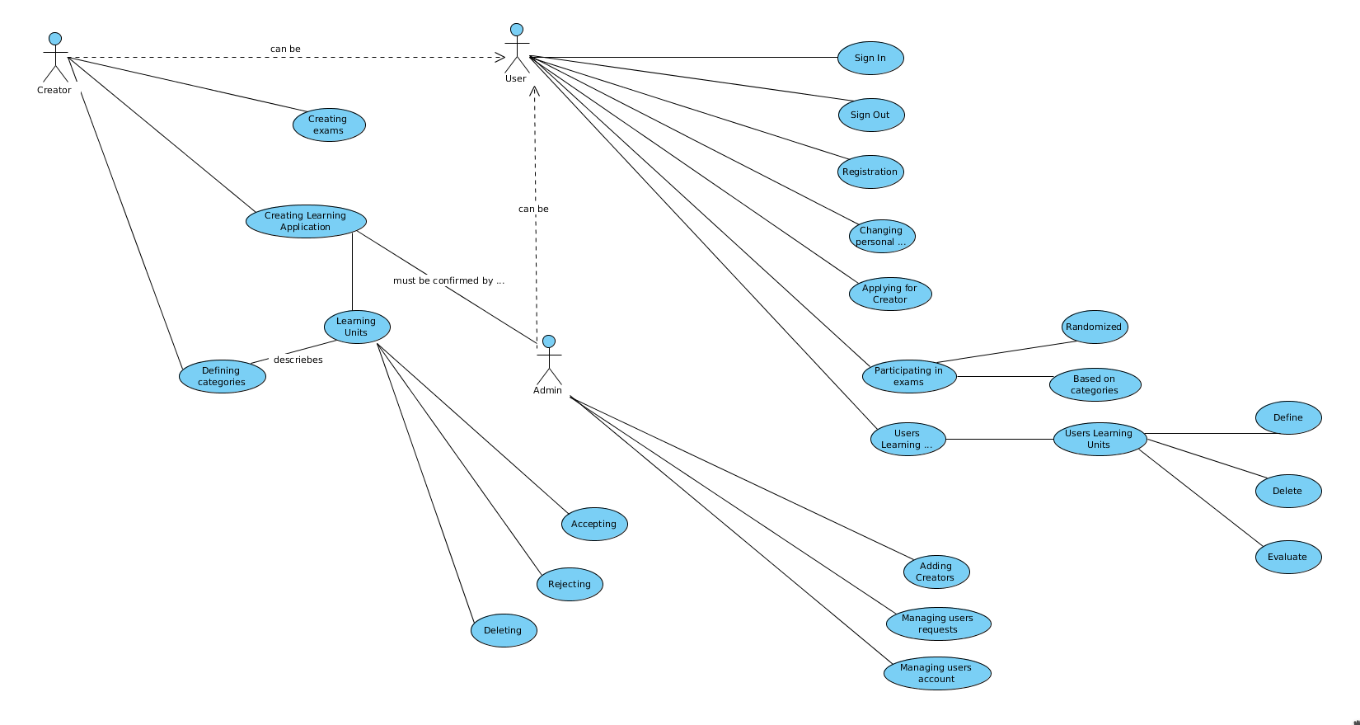

Figure 2. Use Case Diagram in Visual Paradigm

## 

## UML analysis class diagram

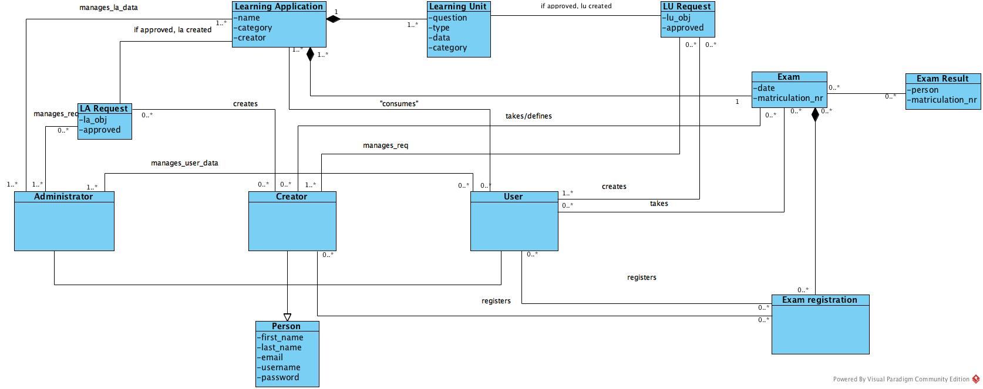

Figure 3. UML Analysis class diagram in Visual Paradigm

## Project plan

|  |  |
| --- | --- |
| What | Who |
| Project Plan | Aleksandar |
| Infrastructure | Stefan, Amir |
| Houses Model | Djordje, Aleksa |
| Testing | Nikola |
| Submission document | Aleksandar |
| GUI | Stefan, Amir |
| Use Case Diagram | Aleksandar |
| UML analysis class diagram | Djordje, Aleksa |
| Screenshots | Nikola |

## Screenshots

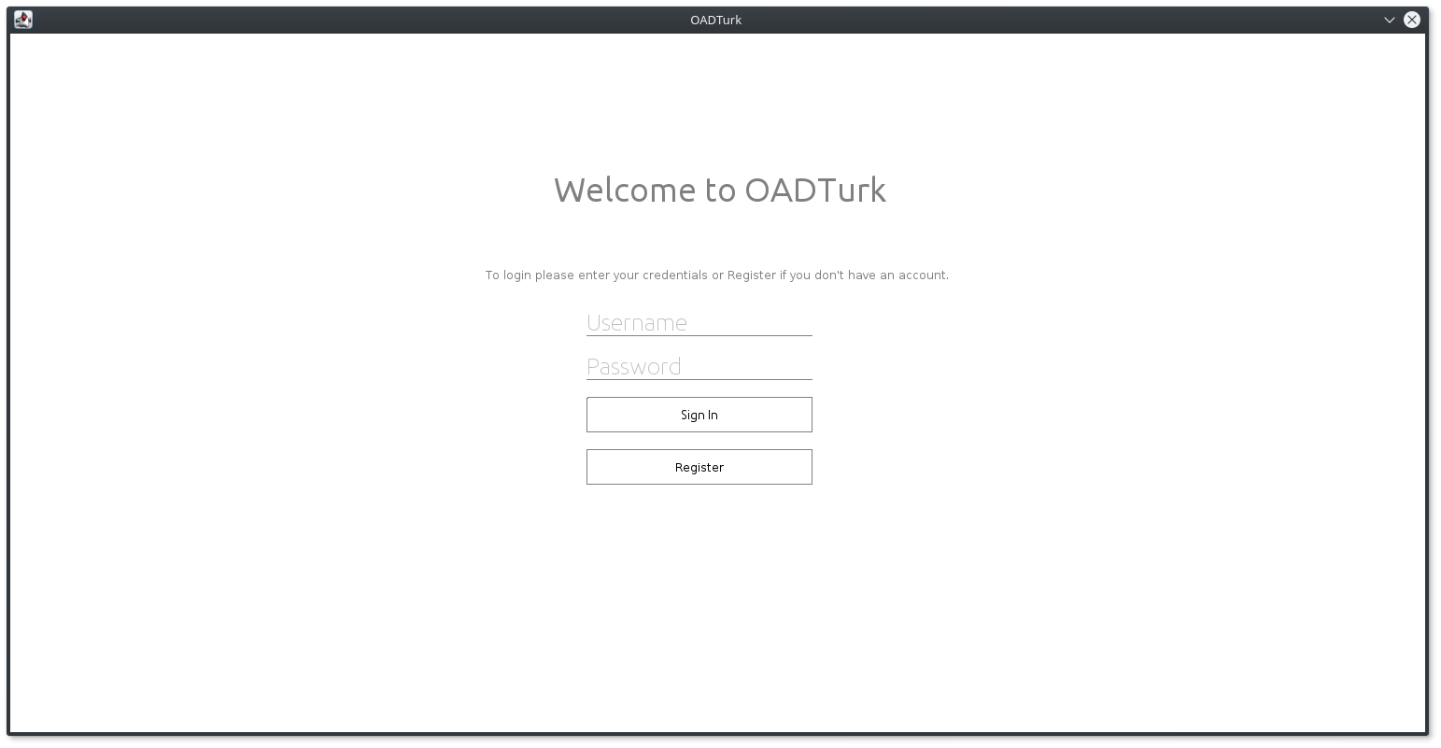

Figure 4. Login page

In the screenshot (Figure 4.) you can see login page for our system. Users cannot consume Learning Applications, or Learning Units before having an account. In this page user is asked to enter login data, username and password. This same page is used for administration login and creators login, based on username which has to be unique system knows which permission logged in user has.

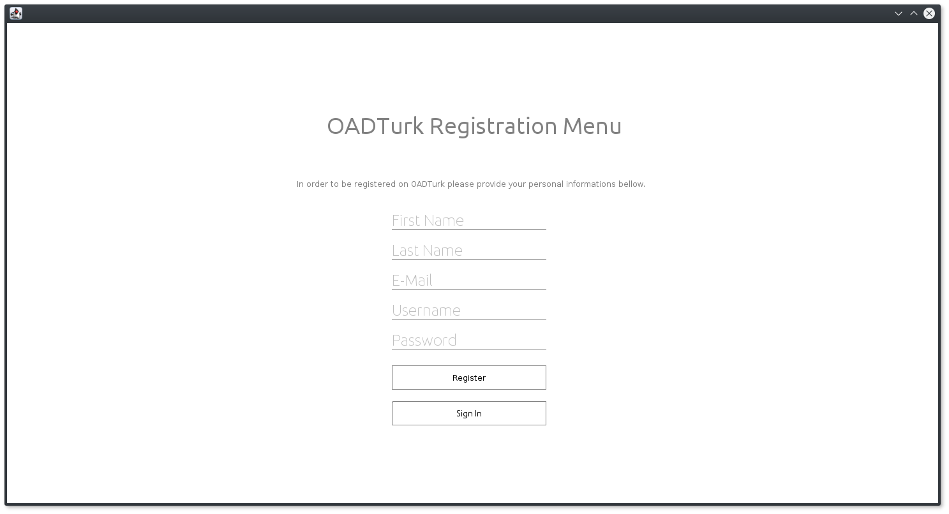

Figure 5. Registration page

For users to be able to obtain login data, registration is needed. Figure 5. shows how registration page looks. Anyone wanting to register need to enter same basic data. First name, last name, email, username and password. Username is unique for every user, so we can differentiate between permissions, in order to know who has the ability to delete something, or change something.

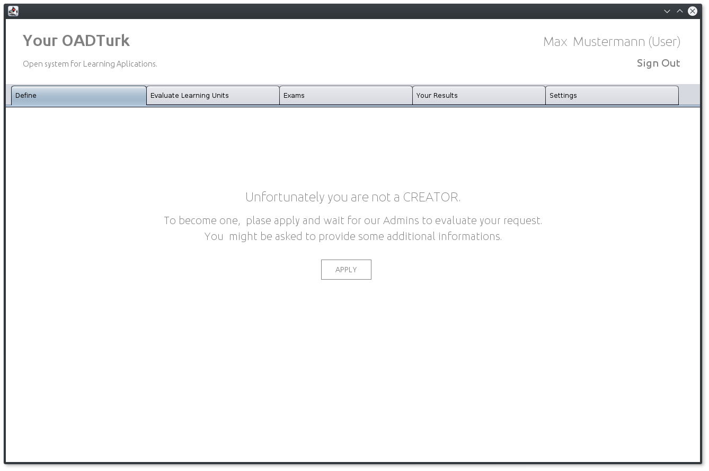

Figure 6. Define page

In example above(Figure 6.) we can see our define page, here creators can create Learning Units, and make requests when creating new Learning Applications. In the future during the implementation this page will not be visible for regular users, however they will have the possibility to make requests when creating new Learning Units.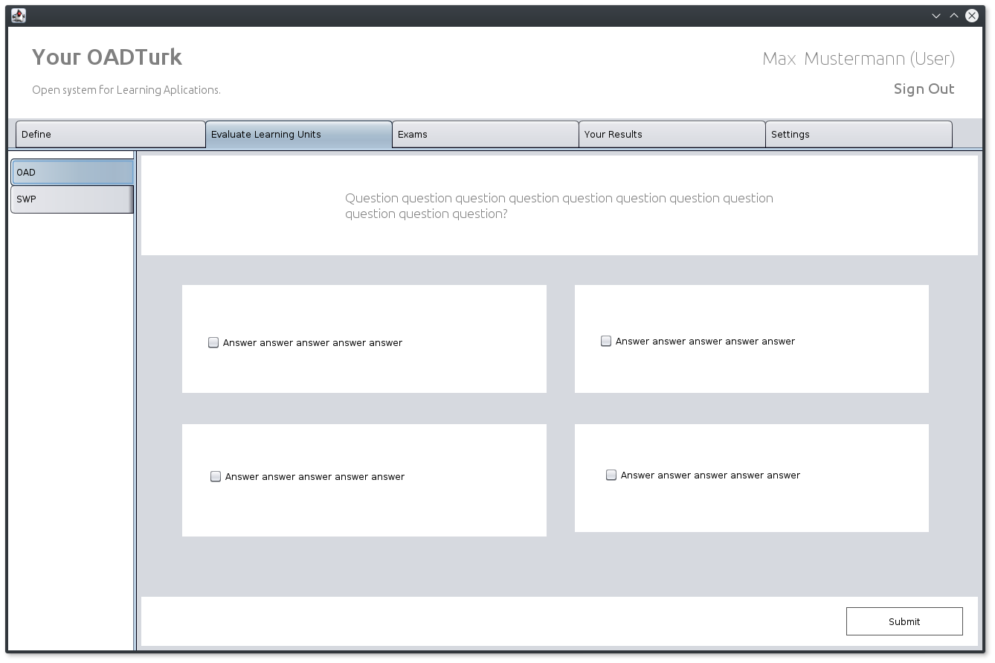

Figure 7. Evaluate learning units tab

Here we can see evaluation look (Figure 7.), on the left hand side we can see that we can choose between different Learning Applications, and for that Learning Application we are presented with its learning unit (question) after answering the question we press submit button to proceed. If we want we can press second button that says create LU, we can create new Learning Unit, and send request for creator to approve.

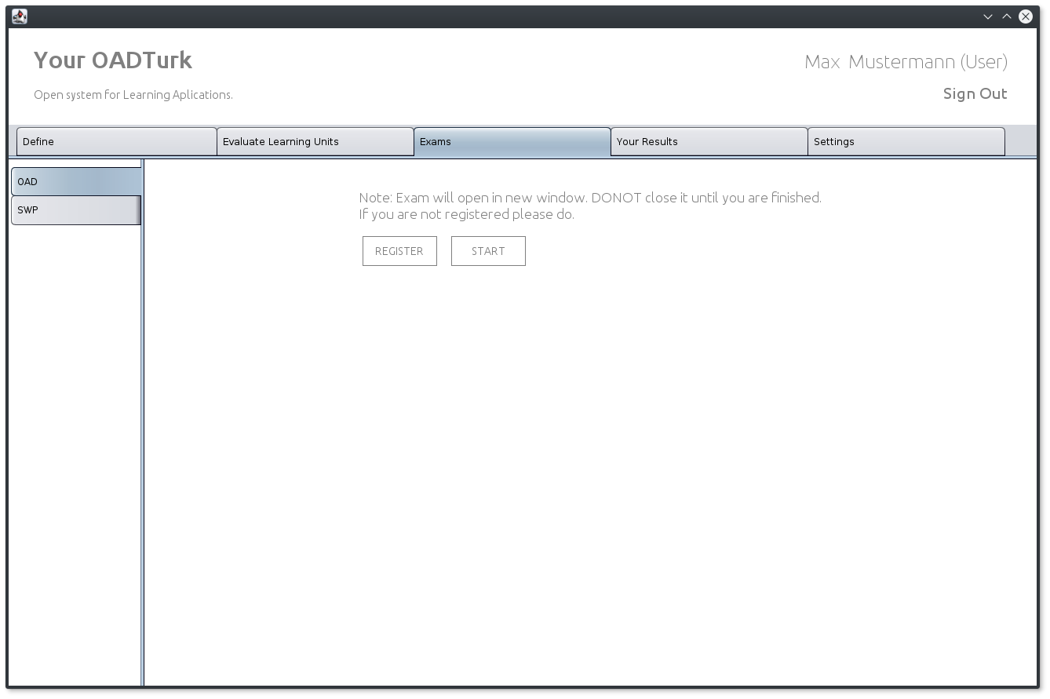

Figure 8. Exams page

Exams page (Figure 8.) allows us to take exams, so we can verify our knowledge. Our exam results are displayed in the results page (Figure 9.).

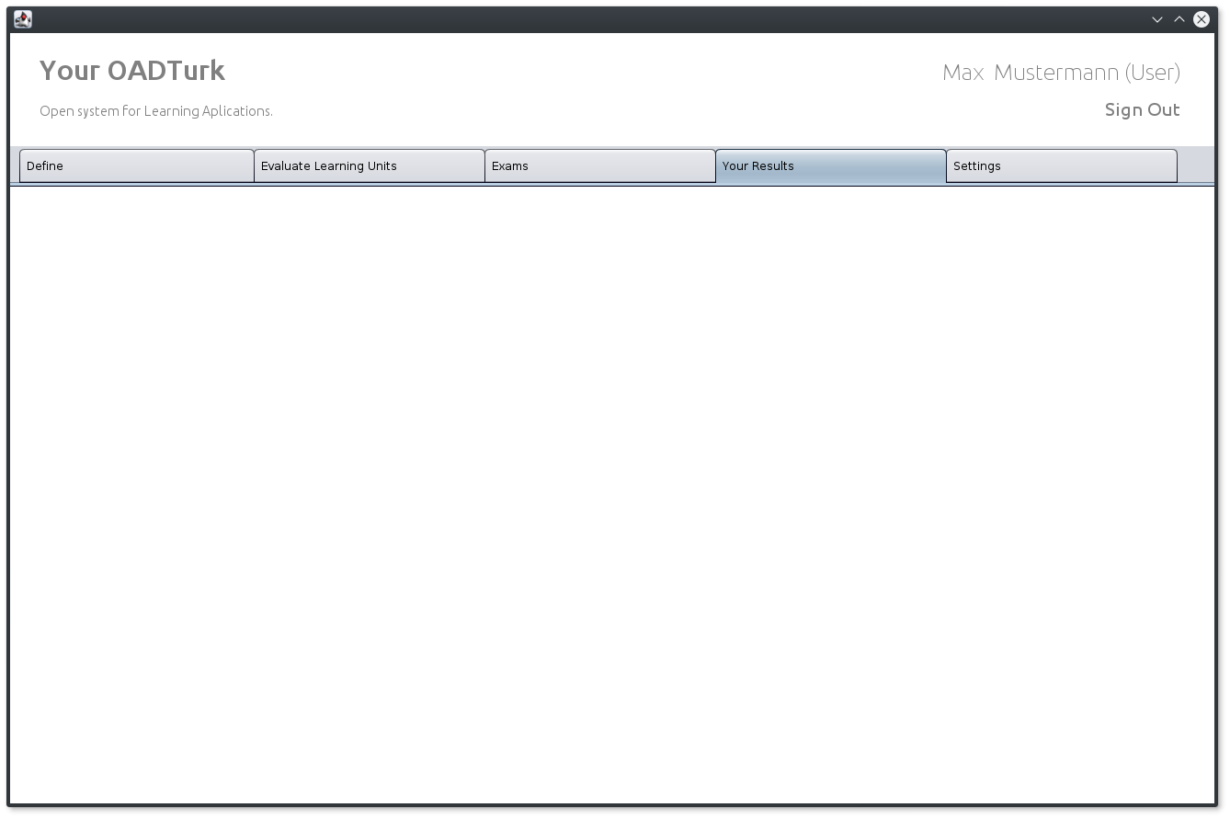

Figure 9. Exam result page

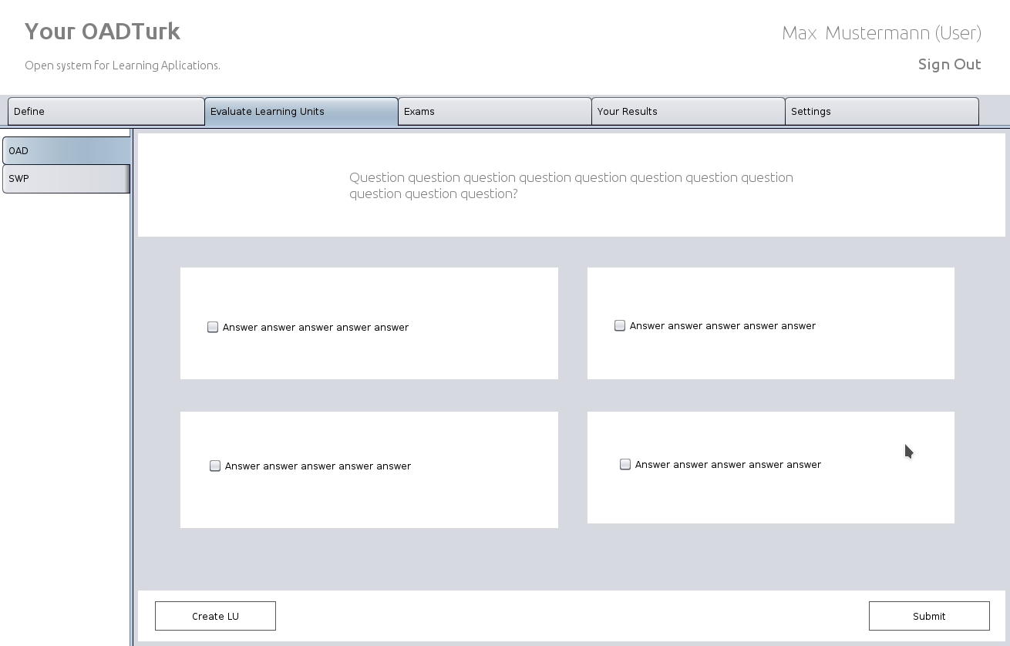

Figure 10. Single exam example

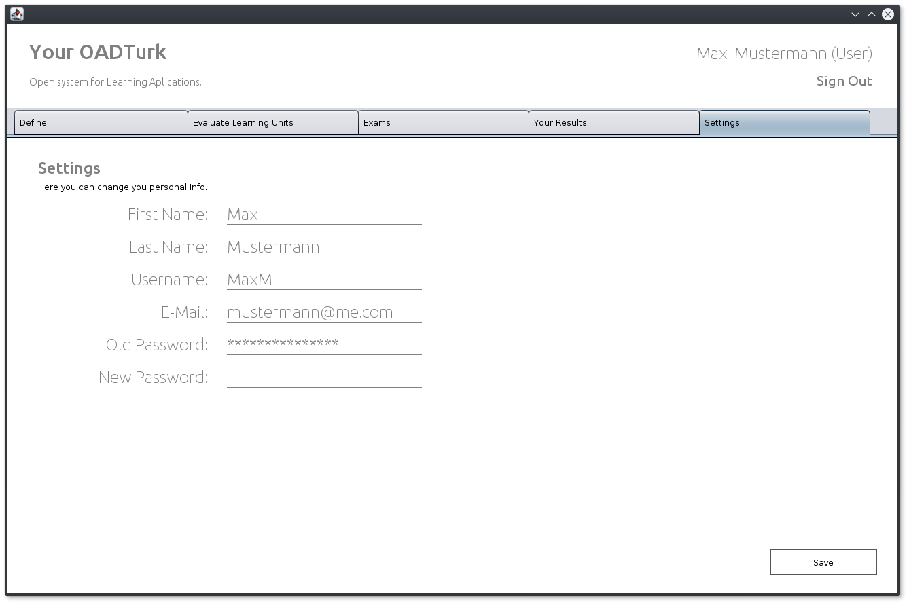

Figure 11. Settings page

In Settings page user is able to change its personal info, such as First Name, Last Name, username, email, and change password. Admin has the ability to change this data too.

## Resource estimation

|  |  |  |
| --- | --- | --- |
| **Iteration** | **Start** | **End/Delivery** |
| Inception | 10.10.2017 | 7.11.2017 |
| Review | 7.11.2017 | 21.11.2017 |
| Elaboration | 7.11.2017 | 5.12.2017 |
| Review | 5.12.2017 | 12.12.2017 |
| Construction | 5.1.2017 | 23.1.2018 |
| Review | 23.1.2017 | 30.1.2018 |

## Risk factors

We have identified following risk factors that could affect our project:

• Activities are missing from scope

• Estimates are inaccurate

• Scope is not well defined

• Team conflict over proposed changes

• Under communication

• Low team motivation

• Project team lack authority to complete work

• Requirements are incomplete

• Decision delays impact project

• Lack of management or control

## Our team

|  |  |
| --- | --- |
| Name | Responsibilities |
| Stefan Gajanovic | Development |
| Amir Mujacic | Development |
| Aleksa Pandurevic | Testing |
| Djordje Rajic | Usability |
| Nikola Balac | Analysis |
| Aleksandar Stojicic | Manager |